# Problem Descriptions.

This problem is from Arora (1989) and Belegundu (1982), which needs to minimize the weight (i.e. f(x)) of a tension/compression spring (as shown in Fig. 4) subject to constraints on minimum deflection, shear stress, surge frequency, limits on outside diameter and on design variables. The design variables are the mean coil diameter D (x2), the wire diameter d (x1) and the number of active coils P (x3). The mathematical formulation of this problem can be described as follows

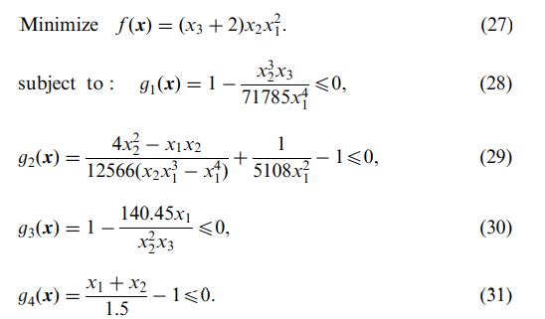

# Figure

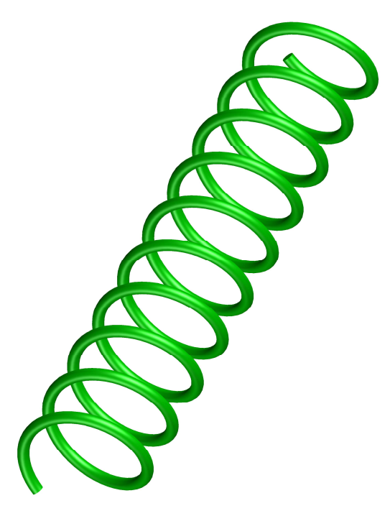

# Results

Kết quả của thuật toán HSSAPSO so với bảng của tác giả Mirjalili

|  |  |  |  |  |  |
| --- | --- | --- | --- | --- | --- |
| **Algorithm** | **Optinum variables** | | | **Optimum weight** | **Rank** |
| **d** | **D** | **N** |
| **HSSAPSO** | **0.051364** | **0.354073** | **11.25612** | **0.012521717** | 1 |
| SSA | 0.051207 | 0.345215 | 12.004032 | 0.0126763 | 5 |
| GSA | 0.050276 | 0.32368 | 13.52541 | 0.0127022 | 8 |
| PSO [104] | 0.051728 | 0.357644 | 11.244543 | 0.0126747 | 4 |
| ES [114] | 0.051989 | 0.363965 | 10.890522 | 0.012681 | 7 |
| GA (Coello) [115] | 0.05148 | 0.351661 | 11.632201 | 0.0127048 | 9 |
| RO [116] | 0.05137 | 0.349096 | 11.76279 | 0.0126788 | 6 |
| Improved HS [117] | 0.051154 | 0.349871 | 12.076432 | 0.0126706 | 3 |
| DE [118] | 0.051609 | 0.354714 | 11.410831 | 0.0126702 | 2 |
| Mathematical optimization | 0.053396 | 0.39918 | 9.1854 | 0.0127303 | 10 |
| Constraint correction | 0.05 | 0.3159 | 14.25 | 0.0128334 | 11 |